4th-Generation Toyota Prius Teardown (Part 1)

Powertrain units miniaturized and lightened to achieve 40km/liter fuel economy

2016/02/29
- Summary
- Powertrain units improved to achieve a JC08 mode fuel economy of 40km/liter
- High performance engine with up to 40% thermal efficiency
- New structure for the hybrid transaxle (loss reduced by about 20%, length shortened by 47mm)
- Miniaturized power control unit
- Compact, high-performance lithium-ion drive battery pack

Summary
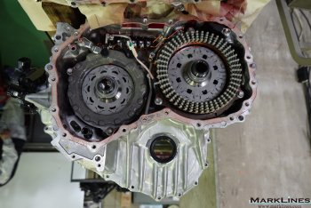 | 
In January 2016, the Hiroshima Industrial Promotion Organization performed a teardown analysis of the all-new Toyota Prius (launched in December 2015). The Prius has been reborn as a completely new car through significant changes such as the adoption of a newly-designed hybrid transaxle, and the use of the new TNGA (Toyota New Global Architecture) platform, all of which was done with the aim of achieving a JC08 mode fuel economy of 40.8km/liter (E grade) and improving the driving performance. (The analysis was performed on the A grade Prius, which has a fuel economy of 37.2km/liter.)
Part 1 of the teardown report will focus on the powertrain units and other technologies that contribute to increasing the fuel economy. Part 2 will look at the TNGA, and the technical innovations that changed the Prius from what was merely a fuel-efficient car, to a fuel-efficient and power-efficient car.
Previous teardown reports:
Daihatsu Move (Feb./Mar. 2015)  (Part 1) Suppliers list, chassis, seats, and electrical components  (Part 2) Turbo engine and CVT with 3-shaft gear train has lightweight and compact design  (Part 3) Linear body structure optimizes space  VW Polo (Dec. 2014)  (Part 1) Engine compartment and driver's seat area  (Part 2) 1.2-liter TDI diesel engine and suspensions  Nissan Note (Sep. 2014)  (Part 1) Major safety technology and advanced driver assistance systems  (Part 2) Drive unit and supercharger  Honda Accord Hybrid (Feb. 2014)  (Part 1) Sport Hybrid i-MMD PCU and vehicle chassis components  (Part 2) SPORT HYBRID i-MMD Battery components and electric servo brake system  (Part 3) SPORT HYBRID i-MMD drive unit | Honda Fit Hybrid (Dec. 2013)  (Part 1) Battery components & brake system  (Part 2) Engine and transmission  Toyota Aqua (Nov. 2012)  (Part 1) Part suppliers and battery components  (Part 2) Hybrid systems behind the 35.4km/liter (53 mpg city) car  Nissan Leaf  (Part 1) Nissan Leaf teardown (Mar. 2012)  (Part 2) main components disassembled (Sep. 2012)  (Part 3) body cutaway (Nov. 2012)

Powertrain units improved to achieve a JC08 mode fuel economy of 40km/liter
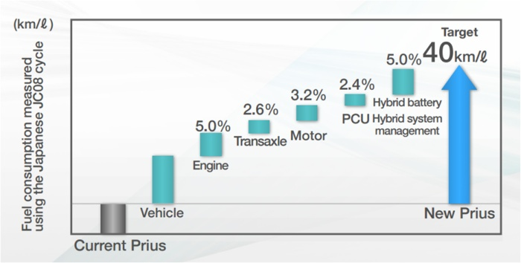
Fuel economy improving effects of powertrain units (Source: Toyota)
The 4th-generation Prius has had collective updates to its fuel efficient technologies, including a redesigned engine; high-optimization and miniaturization of its battery, power control unit (PCU), and motor; and an evolved hybrid system. As shown in the chart above, the vehicle has been revised entirely and its various units improved for higher efficiency and performance, and because of this the new Prius has achieved a JC08 mode fuel efficiency of 40.8km/liter (E grade).

High performance engine with up to 40% thermal efficiency
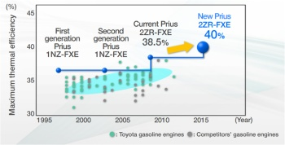
Comparison of maximum thermal efficiency of engines (Source: Toyota)
The 4th-generation Prius is fitted with a 2ZR-FXE 1.8-liter four-cylinder engine, which is the same basic structure as the 3rd-generation Prius, but the new model has achieved a maximum thermal efficiency of 40% through the addition of various improvements.
The exhaust system has a rear-exhaust layout, which is also the same as the previous model. Some of Toyota's small cars have front exhaust systems, but all of the recent FF (front engine front drive) Toyota cars are being standardized to a rear exhaust system layout. A rear exhaust layout is more advantageous because the distance from the engine to the catalyst is shorter, and the exhaust gas temperature is kept at an optimal level that doesn't lower too much. On a separate note, this contrasts with recent Honda vehicles, which have front exhaust, possibly due to layout restrictions.

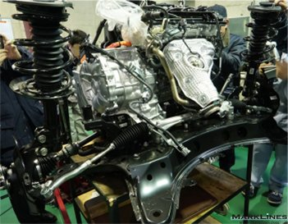  External view of the engine seen from the rear of the vehicle This is the rear exhaust system layout | 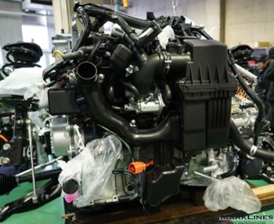  External view of the engine seen from the front of the vehicle.  Intake piping goes from the top of the air cleaner on the right  side to the  throttle valve.

Stronger airflow in combustion chambers
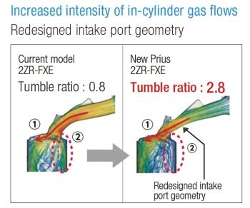 The re-designed intake port shape (Source: Toyota)
The first improvement was changing the shape of the intake port based on an analysis of the "tumble flow," which is the vertical swirl of air-fuel mixture entering the combustion chamber. As illustrated in the image on the right, (1) the airflow was made straight and, (2) the inverse tumble component that blocks the tumble flow was reduced. As a result, the tumble ratio was improved from 0.8 to 2.8, the combustion velocity increased, and induction of a large volume of EGR (exhaust gas recirculation) gas became possible.
The shapes of the combustion chamber and the piston-top surfaces account for the tumble flow described above.

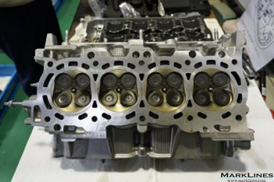  The shape of the combustion chambers | 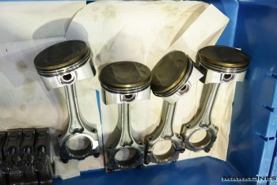  The shape of the piston-top surfaces

Large-volume cooled EGR
The EGR distribution passage in the intake manifold has been restructured to a tournament design. This allows a larger amount of EGR gas to enter evenly into each cylinder.

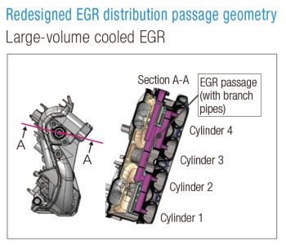  The intake manifold cross-section (Source: Toyota) | 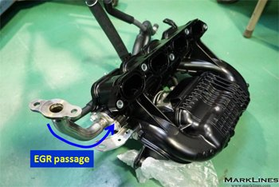  The aluminum pipe at the left connects to the EGR passage

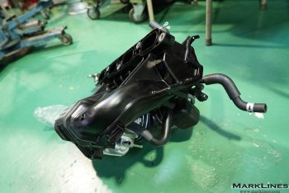  An external view of the intake manifold | 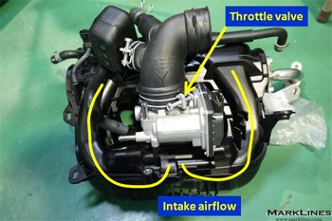  The throttle valve (center)
The intake manifold that directs air into the intake port is shaped so that it branches into two passages from the throttle valve, and supplies intake air into the respective ports after converging once at the collector located immediately before the cylinder head. This design ensures a smooth flow of intake air by increasing the cross-sectional area that the incoming air passes through, which minimizes air resistance and interference between cylinders.

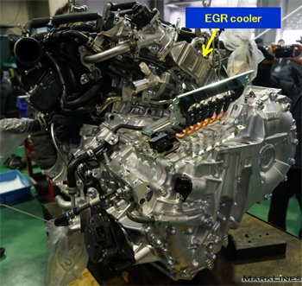  The EGR cooler configured at the back of the engine | 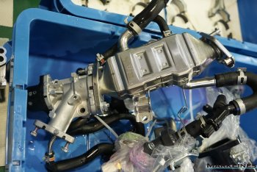  The EGR cooler unit

Adoption of a two-way cooling system
Improving the engine's thermal efficiency is key to raising fuel economy, but this leads to a dilemma where the performance of the heater declines because the heat supplied to it is reduced. The 4th-generation Prius incorporates innovations that maintain sufficient heater performance while increasing the thermal efficiency.
In conventional engines coolant flows through two courses; one to the engine itself and the other to the exhaust heat recovery and heater units. However, the new Prius is fitted with a flow shut-down valve that controls this coolant flow. While previous Prius models coolant did not flow to the heater during warming, heater performance during warm up is improved in the new model by allowing coolant to flow to it as needed.
The new Prius is also fitted with a grille shutter in front of the radiator, which is opened and closed automatically in accordance with driving and warm-up conditions. The grille shutter closes while the coolant is still cold. This reduces the amount of air going through the radiator, which accelerates warm up and reduces heat loss. Moreover, the updated exhaust heat recovery system recovers heat from the exhaust system, which also improves warm-up performance and minimizes heat loss. In this way numerous means are used to reduce heat loss and increase the overall thermal efficiency.
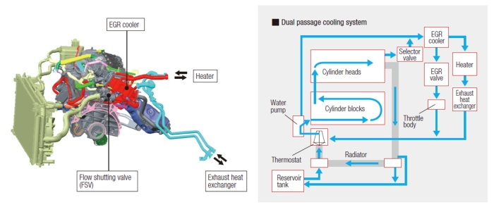
Two-way cooling system (Source: Toyota)

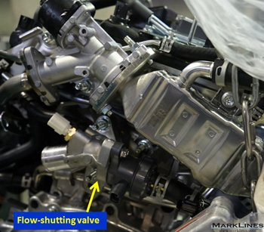  Flow-shutting valve | 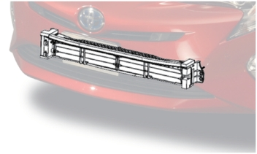  The grille shutter at the bottom of the front radiator  (Source: Toyota)
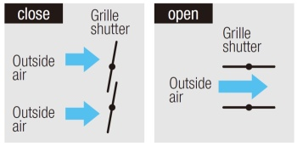  Airflow to the radiator is controlled by the grille shutter (Source: Toyota) | 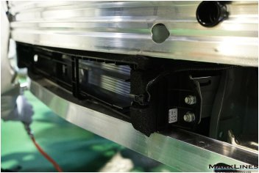  The grille shutter shown with the front bumper removed
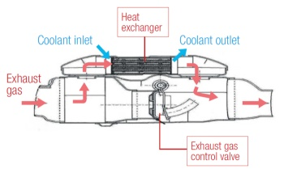  The exhaust heat recovery system (Source: Toyota) | 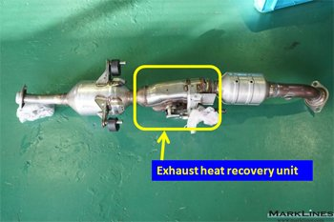  The exhaust heat recovery unit between the main muffler  and catalyst

A newly-designed water jacket spacer optimizes cylinder bore wall temperature
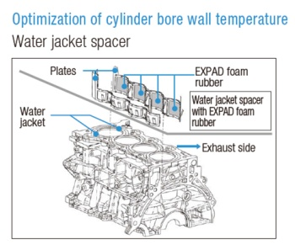 The structure of the water jacket spacer (Source: Toyota)
In order to achieve optimized cooling by means of the cylinder bore region, a water jacket spacer consisting of stainless steel and foam rubber has been adopted. This involves a foam rubber with a brand name of EXPAD being placed in the coolant passage at the bottom of the cylinder bore. This allows a large amount of coolant to flow over the upper part of the cylinder bore, which becomes very hot, and ameliorates knocking by raising the cooling effect. At the same time, allowing a smaller amount of coolant to flow to the lower half portion of the bore to maintain a high temperature. With these techniques, fuel efficiency is achieved by making the expansion factors of the upper and lower cylinder bore even, and piston action friction is standardized at a low level.

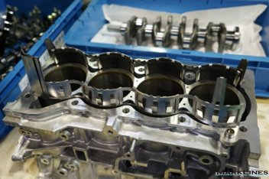 | 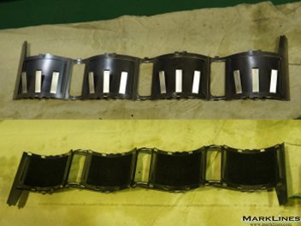
The water jacket spacer that is inserted in the cylinder block

New structure for the hybrid transaxle (loss reduced by about 20%, length shortened by 47mm)
The most significant change in the 4th-generation Prius is the hybrid transaxle. Models until the 3rd-generation Prius used hybrid transaxles with two planetary gears, but in the new Prius, the reduction gear mechanism has been changed to parallel gears, which improves the transmission efficiency. The new design has achieved a reduction in mechanical loss of approximately 20%.
Moreover, the unit had a long length in the previous structure because the drive motor, charging generator, and two planetary gears were arranged in series coaxially. However, this has been shortened in the new Prius by changing to a dual axle structure, with the drive motor and reduction gear fitted separately on parallel shafts, which reduces the unit length by 47mm from 409mm to 362mm. This change makes it possible to layout the engine room framework in an efficient cross-sectional shape.

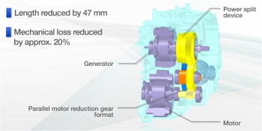 | 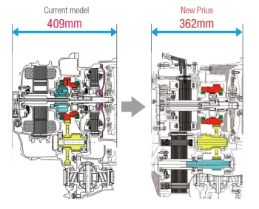
The structure of the hybrid transaxle (Source: Toyota)

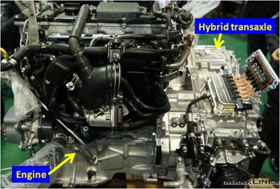  An external view of the hybrid transaxle connected to the engine | 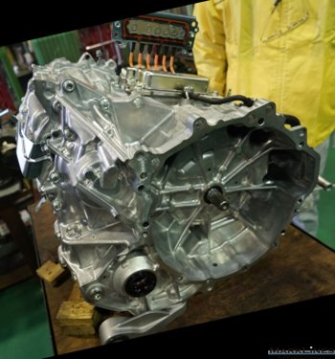  The hybrid transaxle seen from the engine connection side

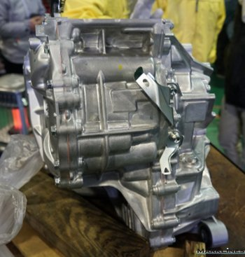  An external view of the hybrid transaxle. The length has been shortened by 47mm | 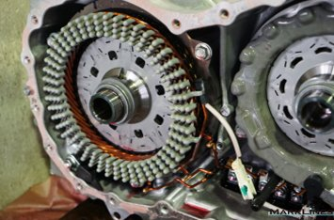  The high-efficiency motor uses a molded winding wire (left).  It adopts a new method for winding wires that uses enamel coating  instead of paper insulator.  It achieves a loss reduction of about 20% and miniaturizes the motor.

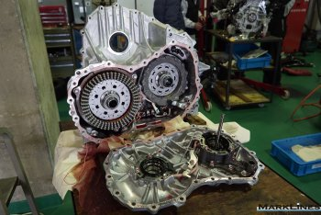  Motor (left) and generator (right) housing | 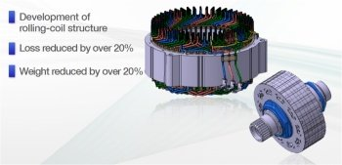  The motor has been miniaturized and made to have output density (Source: Toyota)

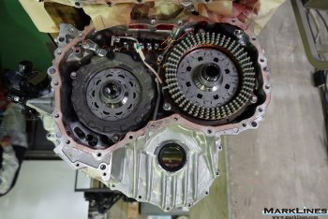  Generator (left) and motor (right) | 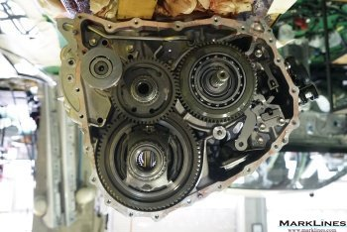  The planetary gear (upper right) and differential gear (bottom)  on the opposite side of the motor housing

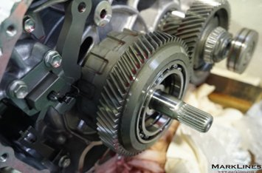  The power split device planetary gear | 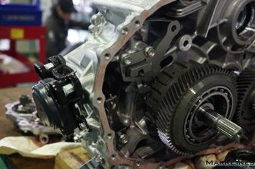  The parking lock mechanism that locks the outer circumference  of the planetary gear

Miniaturized power control unit
An additional loss reduction of around 20% has also been achieved in the power control unit (PCU) through the use of low-loss components and other improvements. The unit size has been reduced 33% from 12.6L in the previous model to 8.2L. This created extra space in the engine room and allowed the auxiliary battery to be shifted there from the luggage space, where it had been placed previously.

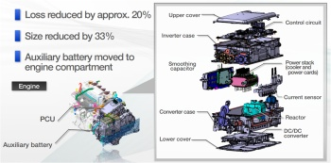  Internal structure of the PCU (Source: Toyota) | 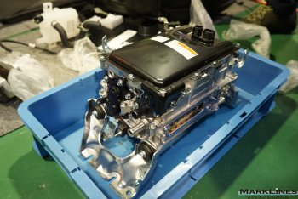  External view of the PCU after removal

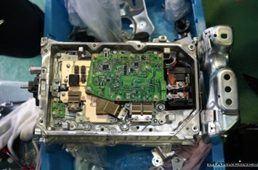  Multi-layered circuitry in the PCU | 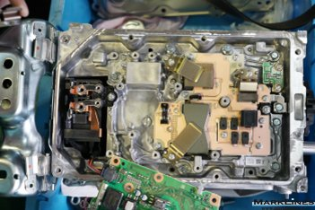  Under the multi-layered circuitry

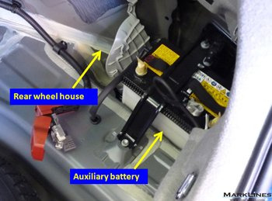  The 3rd-generation Toyota Prius The auxiliary battery was stored in the luggage compartment | 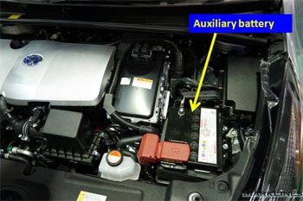  The 4th-generation Toyota Prius The auxiliary battery is stored  in the engine compartment

Compact, high-performance lithium-ion drive battery pack
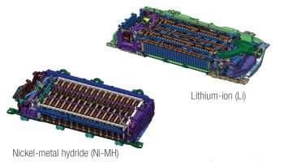 Lithium-ion (left) and nickel metal hydride (right) variants are available for the high-voltage battery (Source: Toyota)
Two types of drive battery packs (lithium-ion, nickel metal hydride) are available for the 4th-generation Prius, and this time the teardown was done with a Prius that used a lithium-ion drive battery. The battery is manufactured by Panasonic, and has a capacity of 3.6Ah, which is a lower specification than the 6.5Ah nickel metal hydride battery, but it is estimated that the actual charging from the generator and energy supply to the drive motor may be done at the same level. The lithium-ion battery has been significantly miniaturized to 30.5L from the 39.4L nickel metal hydride battery in previous models. The new nickel metal hydride battery has also been miniaturized to 35.5 liters, and while it was located behind the rear seats in the previous models, both battery types are now stored snugly under the rear seat cushion in the 4th-generation Prius. This results in increased luggage room for ease of use. The battery service plug for shutting off the high voltage circuit is located behind the finisher under the rear seat so that it is easy to remove when the vehicle is being serviced.

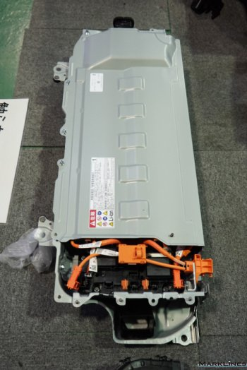  External view of the high-voltage battery pack | 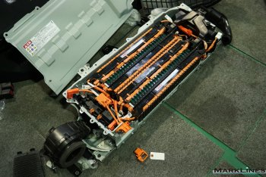  Internal structure of the battery The service plug is colored orange  The high-voltage circuit is shut off when it is removed.

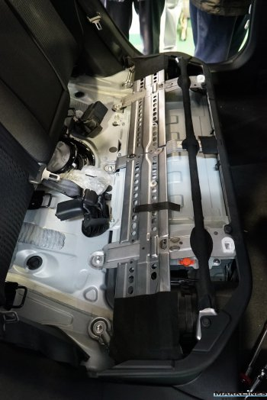  The high-voltage battery stored under the rear seats | 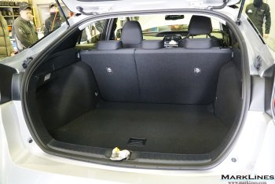  The high-voltage battery is stored under the rear seats to  create more space for luggage

4th-Generation Toyota Prius Teardown (Part 2)

New TNGA platform enhances dynamic performance; advanced aerodynamics and chassis technologies

2016/03/18
- Summary
- Carefully designed double-wishbone rear suspension
- High-rigidity support structure front suspension
- Front axle
- Steering
- Brakes
- Engine mounts
- Aerodynamic technologies that achieve 0.24 Cd

Summary
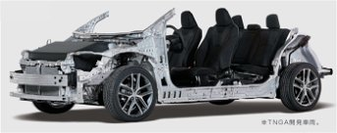
TNGA platform Source: Toyota

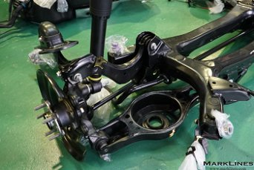
This is a continuation of a report series describing the teardown analysis of the all-new Prius performed in January 2016 by the Hiroshima Industrial Promotion Organization. The first report can be found at the following.
(4th-Generation Toyota Prius Teardown (Part 1): Powertrain units miniaturized and lightened to achieve 40km/liter fuel economy)
This report will introduce the TNGA (Toyota New Global Architecture) platform, as well as its chassis and aerodynamic technologies, which have significantly advanced the Prius's driving performance. Fuel economy was given priority in previous Prius models, but attention was given to areas related to driving performance as well in the 4th-generation Prius, and thoroughly planned out technology that rivals European cars has been worked in throughout the vehicle.
A third report will introduce the autobody and sound insulating technologies in the new TNGA platform.

Previous teardown reports:
4th-Generation Toyota Prius
(Part 1) Powertrain units miniaturized and lightened to achieve 40km/liter fuel economy(Feb. 2016)
Daihatsu Move (Feb./Mar. 2015)  (Part 1) Suppliers list, chassis, seats, and electrical components  (Part 2) Turbo engine and CVT with 3-shaft gear train has lightweight and compact design  (Part 3) Linear body structure optimizes space  VW Polo (Dec. 2014)  (Part 1) Engine compartment and driver's seat area  (Part 2) 1.2-liter TDI diesel engine and suspensions  Nissan Note (Sep. 2014)  (Part 1) Major safety technology and advanced driver assistance systems  (Part 2) Drive unit and supercharger  Honda Accord Hybrid (Feb. 2014)  (Part 1) Sport Hybrid i-MMD PCU and vehicle chassis components  (Part 2) SPORT HYBRID i-MMD Battery components and electric servo brake system  (Part 3) SPORT HYBRID i-MMD drive unit | Honda Fit Hybrid (Dec. 2013)  (Part 1) Battery components & brake system  (Part 2) Engine and transmission  Toyota Aqua (Nov. 2012)  (Part 1) Part suppliers and battery components  (Part 2) Hybrid systems behind the 35.4km/liter (53 mpg city) car  Nissan Leaf  (Part 1) Nissan Leaf teardown (Mar. 2012)  (Part 2) main components disassembled (Sep. 2012)  (Part 3) body cutaway (Nov. 2012)

Carefully designed double-wishbone rear suspension
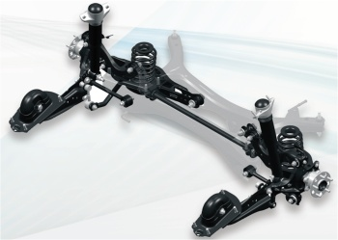
Double-wishbone rear suspension Source: Toyota
Whereas the 3rd-generation model had a torsion-beam system, the 4th-generation Prius is fitted with a double-wishbone rear suspension. The double-wishbone design has a trailing arm that controls the longitudinal motion of the wheel, and three links (lower arm, upper link and control link) that collectively control the lateral motion of the wheel. This is a classical structure for the double-wishbone suspension system of a front engine and front-wheel drive (FF) vehicle. Volkswagen, Mercedes-Benz and Mazda call it a multi-link rear suspension but Toyota traditionally refers to it as a double-wishbone rear suspension.

A special feature of this rear suspension system is the control link being shorter than the lower arm, and since the vehicle front control link has a short rotation radius during a suspension stroke, the rear axle housing control link pivot comes inward. Because of this the rear tire has a toe-in orientation (slightly directed to the inside of the vehicle), and this structure enhances the car's handling stability.

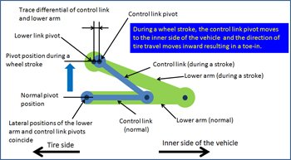  Characteristics of double-wishbone rear suspension on the right side as viewed from the vehicle front | 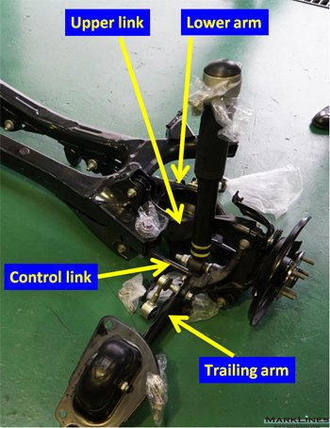  Rear suspension
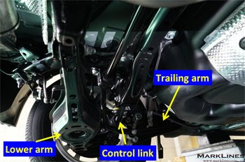
Left side of the rear suspension as viewed from the vehicle center

The trailing arm has a curved shape because the point where it is fitted to the chassis is concealed in the side member.

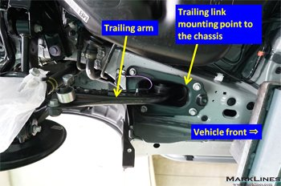  Trailing arm mounting point to the chassis | 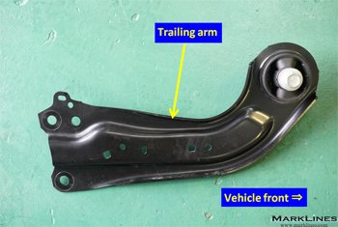  Trailing arm
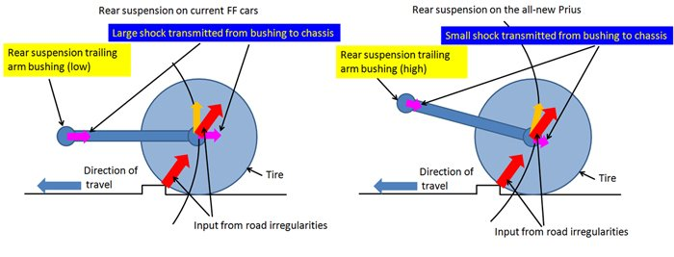
Characteristics of the double-wishbone rear suspension on the all-new Prius
(suspension on the left side of the vehicle)

Toyota's FF model rear suspension system for small cars, including Prius models through the previous generation, used a simple, low-cost torsion-beam suspension. However, double-wishbone suspensions are used in FF models in vehicle from the C-segment and higher, where driving performance is critical. These models include the Lexus CT200h and the second-generation Auris as well as the higher-end Harrier and the Vellfire.
The rear suspension used on the 4th-generation Prius is based on the one used on the Lexus CT200h, although the trailing arm mounting to the chassis at the front has been moved to a higher position. When the car goes over a step on the pavement and the suspension strokes, the trailing arm strokes upward as it arcs in a rear-diagonal orientation. This mounting position change reduces the longitudinal shock acting on the trailing arm bushing and improves the ride quality. This design also reduces the amount of lift on the rear suspension when the brakes are applied, which contributes to improved braking stability.

The shock absorber on the CT200h is mounted to the outside of the lower arm coil spring, but the new Prius has its shock absorbers mounted directly to the rear axle housing. Whereas only 70 to 80% of the wheel stroke is transferred to the shock absorber in previous models, it is nearly fully transmitted in the new Prius, and this allows full performance to be extracted through greater tuning freedom. | 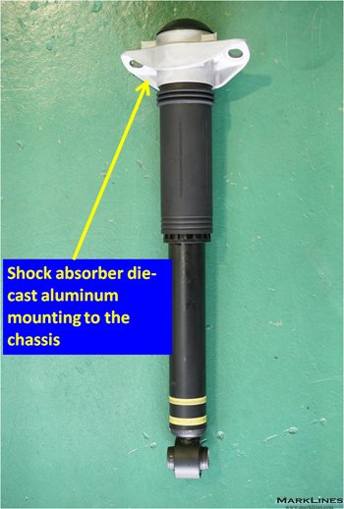  Rear shock absorber (supplied by KYB Corp.)
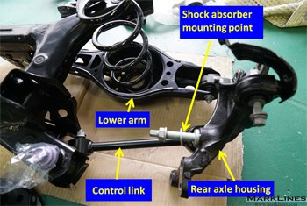
Shock absorber mounting on the rear axle housing
The shock absorber, supplied by KYB Corporation, is mounted to the chassis by means of a die-cast aluminum mounting, which increases rigidity and accounts for drawing out shock absorbing performance for very small strokes. Moreover, the upper rubber caps and dust boots are designed to thoroughly insulate road noises and the operational sound of the shock absorbers.

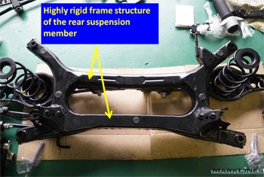
Rear suspension member
The parallel-cross frame that forms the main structure of the rear suspension member has a large sectional area, and connects at longitudinal and lateral points almost linearly. The longitudinal distance of the frame is relatively large for FF vehicles of this class. This increases the support rigidity of the suspension, which helps increase the handling stability and ride comfort. It is also shaped to effectively suppress sound and vibration from the tires.

Another reason for adopting the double-wishbone suspension is its suitability for AWD vehicles. The torsion-beam suspension used in previous models does not work for driven wheels, but through adoption of the double-wishbone rear suspension system, the suspension package for 2WD models can be used on AWD models as well with minor modifications. The AWD model has an electrically-controlled all-wheel drive system in which the rear wheels are driven by "E-Four" motor.
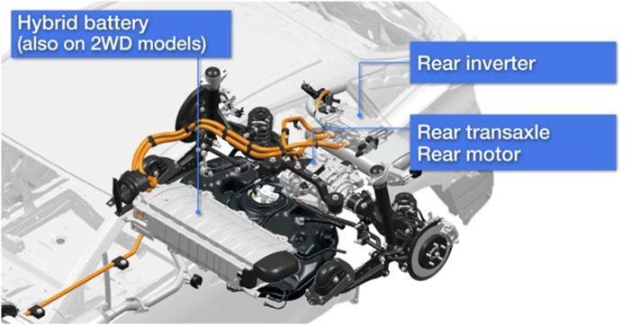
Electrically-controlled all-wheel drive system Source: Toyota

The result of incorporating these various improvements is, the rear suspension system on the Prius has a link arrangement that is very close to the multi-link rear suspension system on the VW Golf. A similar link layout is found on MFA platform models like the Mercedes-Benz A-Class, and on models like Mazda Atenza, so it could be said that this link arrangement has become standard for the rear suspension systems of upper class FF models. While fuel economy was the key concern in previous Prius models, and driving performance a low priority, the 4th-generation Prius represents a shift to emphasizing those other aspects as well.

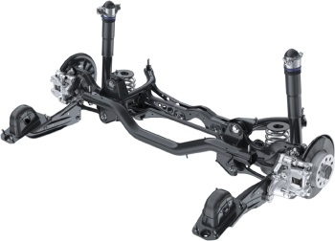  Multi-link rear suspension used on VW Golf  Source: VW | 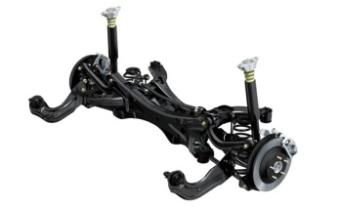  Multi-link rear suspension used on Mazda Atenza  Source: Mazda

High-rigidity support structure front suspension
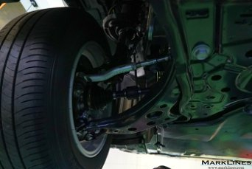  Front strut suspension | 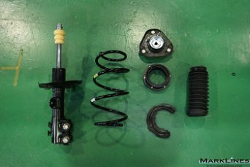  Strut components
The front suspension on the 4th-generation Prius is a strut suspension that is almost unchanged from the previous model. This is a structure commonly used on FF models, in which the coil spring is mounted on the same shaft as the shock absorber, and longitudinal and lateral forces are borne by a transverse link.

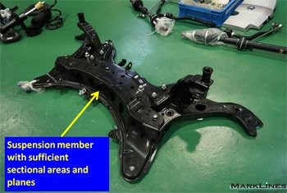  Front suspension member  A large sectional area and top and bottom planes increase the bearing rigidity of the suspension. | 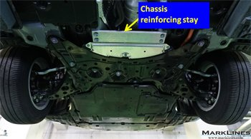  Front suspension member  A reinforcing stay is used to connect the front of the suspension member to the front cross member.
Front suspension systems around the world have a similar structure, but the front suspension on the Prius is unique in that it has a high-rigidity suspension member. Like the VW Golf and Mercedes-Benz A-Class, the basic shape forms a flat surface that is the same height with the bottom of the car's floor, and that structure generally supports the transverse link, but compared with FF cars in the same class, the sectional area is larger.
The suspension member has a large plane at both the top and bottom that form a strong structure. The steering gear is mounted to the top plane.
The suspension member is mounted to the chassis at an area where body rigidity is high. In the rear the side member is mounted to a rigid area on the chassis where it lowers from the engine compartment to the floor surface.
Moreover, the floor tunnel directly behind the suspension member mounting area has an extruded aluminum reinforcing stay that connects the left and right components, which increases the body rigidity near the suspension member mounting point.

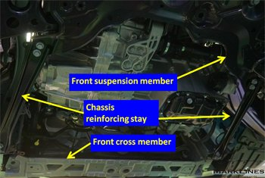  A reinforcing stay is used for longitudinal connection of the suspension member and front cross member. | 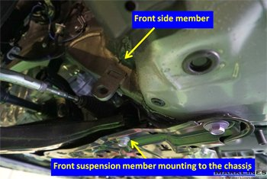  Front suspension member rear mounting point with a reinforcing stay
Reinforcing members are added to increase rigidity and ensure stronger mounting to the chassis. This helps increase steering response, and insulates sound and vibration from the tires to improve ride comfort and quietness.

Front axle
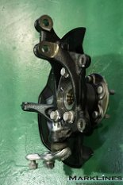 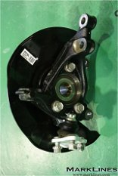
Front axle
The front axle has a unit bearing bolted to the cast iron axle housing at three points. Unit bearings are often press-fit into the axle housing in recent vehicles, but the unit bearing on the Prius has an orthodox bolt fastening structure.
The suspension ball joint is also bolted to the transverse link at three points. Suspension ball joints are also often press-fit to the transverse link on other recent vehicles, but the conventional bolting method was chosen for the Prius, possibly due to consideration of ease of assembly.

Steering
The steering power assist is electric power steering fitted to the column shaft rather than the steering gear itself. The steering rack is rigidly-connected directly to the suspension member without a rubber insulator in order to increase the steering rigidity. Both the steering gear and the steering column with electric power steering are supplied by JTEKT Corporation.

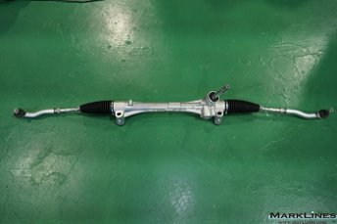  Steering gear | 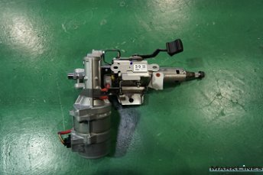  Steering column with electric power steering

Brakes
Both the front and rear have fist type disc brakes. A peculiar characteristic is changing the parking brakes from conventional rear drum-in disc brakes, to incorporating the function into the fist break piston component. When the parking brake wire cable is pulled, the brake pistons are moved through the rotational mechanism integrated in the brake pistons.

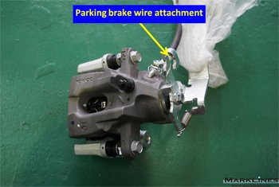  Rear disc brake (supplied by Tokico)  The same pistons are used to apply parking brakes. | 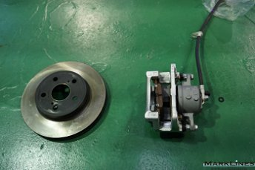  Front disc brake
In the case of hybrid vehicles and electric vehicles, hydraulic braking and regenerative braking must be controlled in coordination. For this reason, a hydraulic booster is used in place of the conventional vacuum servo that uses vacuum from the engine. When the brake pedal is pressed, the electronically controlled brake system determines how much braking force is required from the hydraulic and regenerative brakes according to the driving conditions. The active brake booster (supplied by Advics) activates the hydraulic brake accordingly. The system-specific hydraulic power supply is built into the ABS/ESP control actuator unit.

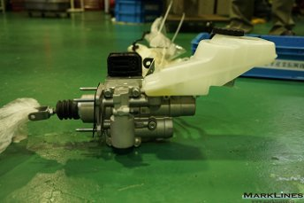  Active brake booster (supplied by Advics) | 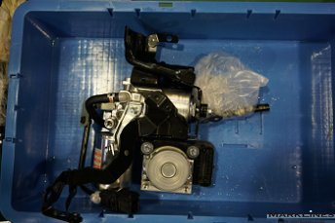  ABS/ESP control actuator

Engine mounts
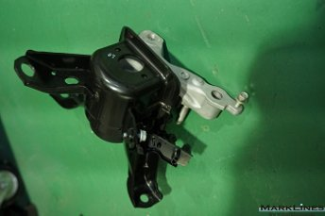  Fluid-filled engine mount (engine side) | 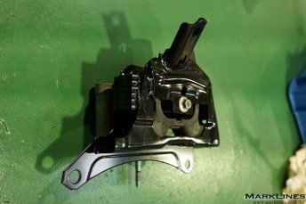  Engine mount (transaxle side)
Two types of engine mounts are used; fluid-filled engine mounts at the engine mounting points on the right-side of the vehicle, and solid rubber mounts at the transaxle mounting points on its left-side. Both types of engine mounts are located near the principal axis of inertia that is the central axis of inertial weight for the engine and transaxle unit. Mounts on the chassis side are located at robust points of the right and left side members, which help reduce vibration transmission.

Aerodynamic technologies that achieve 0.24 Cd
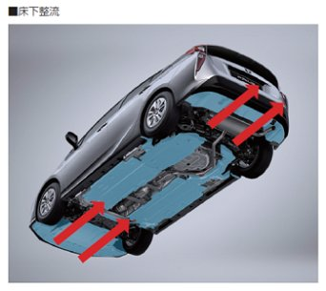
Underfloor covers forming a flat bottom Source: Toyota
The 4th-generation Prius has achieved a drag coefficient (Cd) value of 0.24 through various innovations. Among the improvements to the aerodynamic performance, the one worthy of the most attention is the smooth underfloor flow. From front to back, the underfloor has aerodynamic components set to line up flat to form a flat bottom. From the tip of the front bumper to the suspension members, everything other than the range of tire movement is completely flat.
An easily detachable engine oil change access cover is provided in the engine underfloor cover at the right side of the vehicle. The underfloor covers are made of polypropylene, and are designed to reduce not only the Cd value, but also the lift during high-speed cruising. This increases the high-speed stability dramatically.

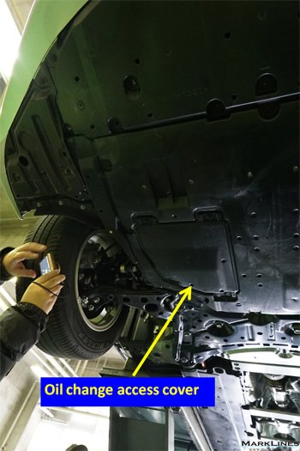  Oil change access cover | 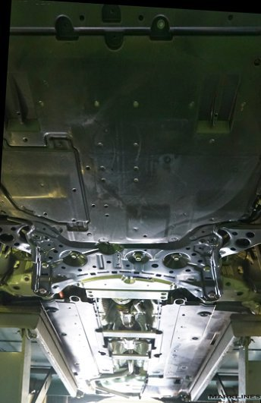  Underfloor covers placed from front to rear

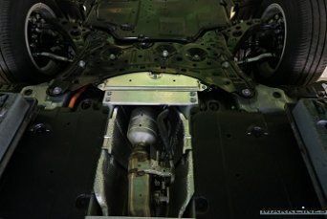  Suspension member area | 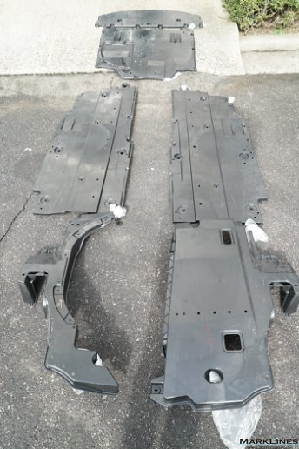  Underfloor covers (front, center, rear)
The suspension member design also takes aerodynamics into account. Its bottom is made flat to ensure a smooth flow of air from the engine underfloor cover. Excluding the central tunnel, polypropylene underfloor covers are used on both sides in the space between the back part of the suspension member and the fuel tank under the rear seat.

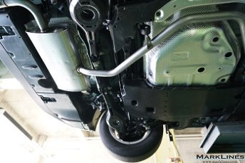
Bottom view of the rear suspension area
The fuel tank has a flat bottom. Uneven surfaces are covered to ensure smooth flow of air from the front undercover. The rear suspension area, excluding the lower arm, is also entirely covered, and the bottom of the lower arm has been flattened to make the underside of the chassis as flat as possible. The rear muffler has been positioned behind the rear suspension in consideration of air flow, and smoothly connects to the undercover below the trailing-edge rear bumper.

In addition to the smooth underfloor airflow, the following designs have been incorporated to improve the aerodynamics.
 | 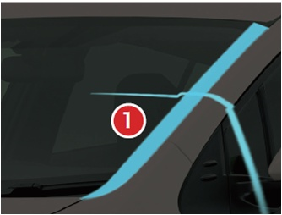
(1) A-pillar: Steps are eliminated and aerodynamic garnish has been arranged on the inner side (RH illustration courtesy of Source: Toyota)

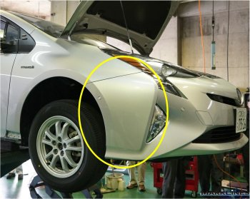 | 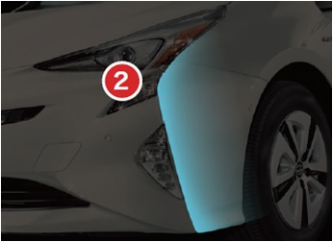
(2) Front bumpers: Shaped with optimal angles to provide a smooth transition of air to the front tire (RH illustration courtesy of Source: Toyota)

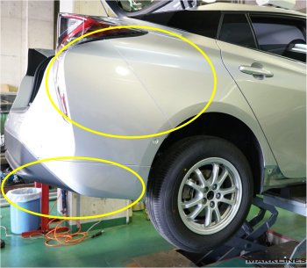 | 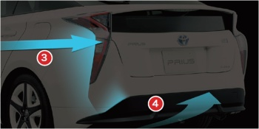
(3) Rear bumpers: Shaped to ensure a smooth flow of air to the rear (RH illustration courtesy of Source: Toyota)
(4) Rear bumpers: Shaped to optimize air flow in the underside

4th-Generation Toyota Prius Teardown (Part 3)

Body structure based on TNGA, sound insulating, absorbing and damping technologies

2016/04/11
- Summary
- Shock absorbing structure for the front end and engine compartment
- Rugged dash panel structure
- Floor panel structure
- Looped structure for the body side
- Luggage room structure
- Sound insulation/absorption and damping materials for cabin quietness

Summary
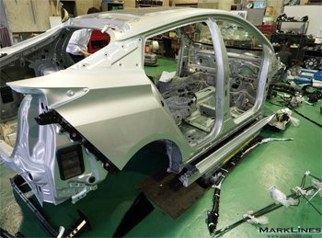 | 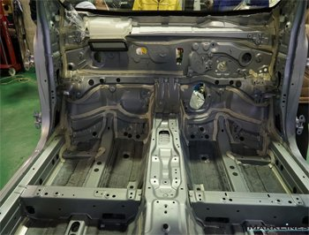
Body structure of the new Prius

This is a continuation of a report series describing the teardown analysis of the all-new Prius performed in January 2016 by the Hiroshima Industrial Promotion Organization. The first and second reports can be found at the following links.
(4th-Generation Prius Teardown (Part 1): Powertrain units miniaturized and lightened to achieve 40km/liter fuel economy, (Part 2): New TNGA platform enhances dynamic performance; advanced aerodynamics and chassis technologies)
This report introduces technologies related to the autobody structure, which could be said to be core to the Toyota New Global Architecture (TNGA) platform. The body structure of the new Prius has technologies woven into it that were carefully planned out to accomplish three goals. These are: (1) collision safety, (2) creating a rugged body with the high tensile strength necessary for dynamic vehicle performance, while at the same time (3) improving the fuel economy through weight reduction. Among these goals, the second one in particular is a new endeavor for the company. The 4th-generation Prius adopts new design features like the expanded use of ultra-high tensile steel, a looped structure framework based on the TNGA, and laser spot welding, which increase the torsional rigidity of the body by approximately 60 percent. This report will go on to introduce the characteristics of the sealing and damping materials used in the body as well as technologies to improve cabin quietness, and the sound insulating and absorbing materials that were enhanced in the 4th-generation Prius.
The following report (Part 4) will present photographs of components and parts, as well as a list of the main parts suppliers from the vehicle teardown, including those that were not mentioned in the three reports on the new Prius through this current one.

Previous teardown reports:
4th-Generation Toyota Prius
(Part 1) Powertrain units miniaturized and lightened to achieve 40km/liter fuel economy (Feb. 2016)
(Part 2): New TNGA platform enhances dynamic performance; advanced aerodynamics and chassis technologies

Daihatsu Move (Feb./Mar. 2015)  (Part 1) Suppliers list, chassis, seats, and electrical components  (Part 2) Turbo engine and CVT with 3-shaft gear train has lightweight and compact design  (Part 3) Linear body structure optimizes space  VW Polo (Dec. 2014)  (Part 1) Engine compartment and driver's seat area  (Part 2) 1.2-liter TDI diesel engine and suspensions  Nissan Note (Sep. 2014)  (Part 1) Major safety technology and advanced driver assistance systems  (Part 2) Drive unit and supercharger  Honda Accord Hybrid (Feb. 2014)  (Part 1) Sport Hybrid i-MMD PCU and vehicle chassis components  (Part 2) SPORT HYBRID i-MMD Battery components and electric servo brake system  (Part 3) SPORT HYBRID i-MMD drive unit | Honda Fit Hybrid (Dec. 2013)  (Part 1) Battery components & brake system  (Part 2) Engine and transmission  Toyota Aqua (Nov. 2012)  (Part 1) Part suppliers and battery components  (Part 2) Hybrid systems behind the 35.4km/liter (53 mpg city) car  Nissan Leaf  (Part 1) Nissan Leaf teardown (Mar. 2012)  (Part 2) main components disassembled (Sep. 2012)  (Part 3) body cutaway (Nov. 2012)

Shock absorbing structure for the front end and engine compartment
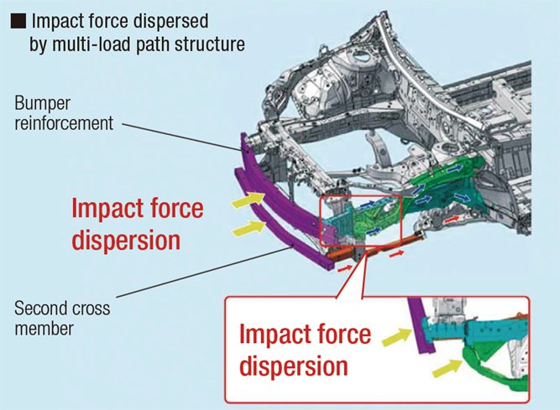
Vehicle front shock absorbing structure Source: Toyota Motor Corp.
To begin, the body structure at the vehicle front will be examined, starting with a description of the impact absorption configuration during a frontal collision. As in the previous models, the basic concept is to minimize the impact energy reaching the passenger cabin by absorbing the direct impact of the crash with the engine compartment, which extends from the tip of the bumper to the dash panel. The 4th-generation Prius has a framework fortified for oblique offset crashes. This is achieved by using more rugged bumper reinforcement, and adding a second cross member and reinforcing stays that absorb impact energy from it. The bumper is connected to the suspension members via stays so that the collision energy is scattered and absorbed. This specific design is aimed at the 'post-crash co-existence' of two cars with different height and weight.

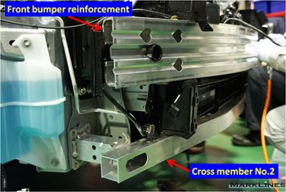 | 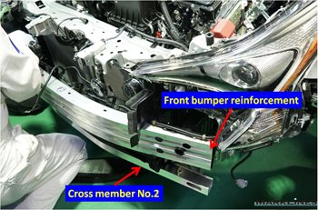
Front bumper reinforcement and second cross member (No. 2)
Removing the front bumper fascia, which is integrated with the front grille, exposes the front bumper reinforcement and second cross member.

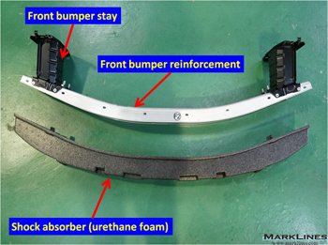 | 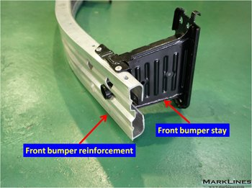
Front bumper reinforcement
The front bumper reinforcement is made of extruded aluminum, and front-to-rear force is borne by steel bumper stays with a closed cross section (see Note). The front of the bumper reinforcement is covered with urethane foam, and during a low-speed collision, the bumper fascia and the urethane foam yield, but the body remains intact, so that the damaged area is minimal.
(Note) Closed cross section structure: Unlike open square sections (open at one side) or H-shaped sections, a closed-section structure is closed on all sides but hollow inside like a steel pipe. It is stronger and more rigid than even open cross section structures that have open square sections or H-shaped sections with the same cross-sectional area.

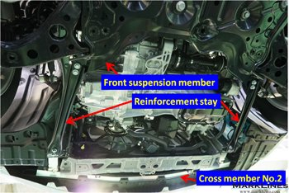  Body structure viewed from under the engine compartment | The reinforcing stays that connect the second cross member and front suspension members are set up to absorb impact energy  from the second cross member. In addition to crash safety  performance, the reinforcement stays are used to increase the  support stiffness of the front suspension and could contribute to  better handling.

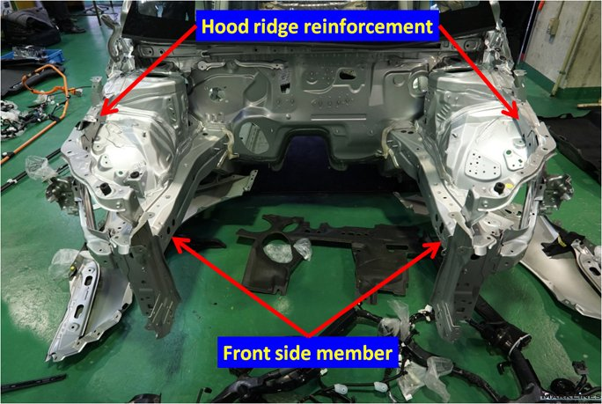
Framework of the engine compartment
The impact energy from the bumper reinforcement is transmitted by the bumper stays and borne by the front side members that are aligned with them. Since energy is also distributed to the hood ridge reinforcement positioned in the top end of the hood ridge, a peculiar characteristic of the new Prius is that the front edge of the hood ridge reinforcement forms part of the closed cross section that extends to the front side member and bumper stay joints.

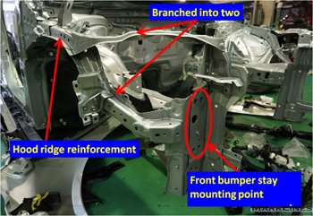 | 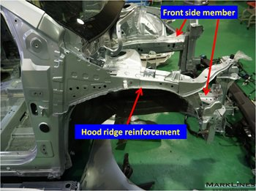
Hood ridge reinforcement
The hood ridge reinforcement splits in two to connect to the side member and bumper stay joint framework mentioned above, and the top of the radiator panel framework. This design not only absorbs impact energy but also increases the torsional rigidity of the vehicle front.

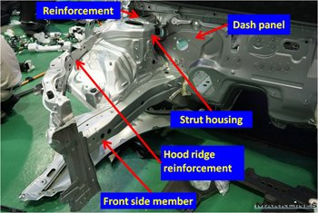 | 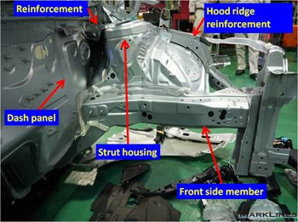
Right-side strut housing area | Left-side strut housing area
The strut housing structure of the new Prius is the same as that of a front-engine, front-wheel drive vehicle, but what is different is that it is located closer to the dash panel and connected to it with reinforcing materials. The dash panel upper is split and connects the top of the dash panel and the right and left strut housings. This design helps increase the torsional and flexural rigidity. It works the same way as the strut tower bar on high-performance cars and sports cars, and improves the handling performance by minimizing the displacement of the body from suspension impact.

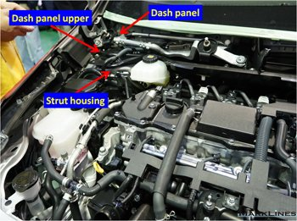 | 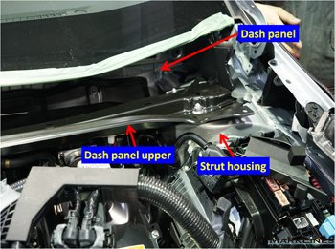
Dash panel upper connecting RH and LH strut housing and dash panel

Rugged dash panel structure
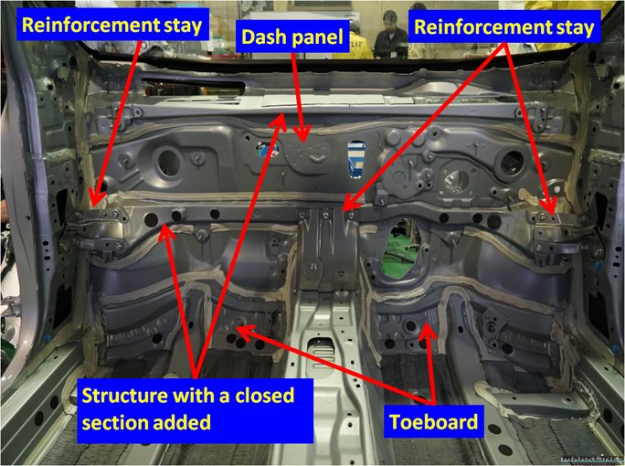
Dash panel viewed from the cabin
For frontal collisions, impact energy is absorbed by body structure deformation in the engine compartment, but at the same time, deformation of the cabin section needs to be restrained by a rugged structure in order to maintain the space for the occupants. The two sections are separated by the dash panel. The toeboards at the bottom of the inner side are made of 1.5 GPa-class hot-stamped ultra high-tensile steel.
The lower part of the dash panel connects to the side member, which has a large amount of impact energy transmitted to it, and is a key area for minimizing cabin deformation. Until now the structure of dash panels for general vehicles was of a thin sheet with simple reinforcements, but the dash panel on the new Prius has closed cross sections that connect the dash sides and the tunnel between the toeboards. Closed cross sections are also used on the dash sides at the center area and two places on the top in the vertical direction to increase rigidity. Additionally, bolted reinforcement stays are used for the right and left edges of the central framework and the tunnel joint area to further increase the rigidity of the central framework.

Moreover, autobody sealer is applied extensively to fill gaps at the edges of the panel and framework joints that make up the dash panel mentioned above. The use of sealer is increased around the dash panel to prevent the intrusion of sounds from the engine compartment and improve the car's quietness. Sealer is also used in the floor to keep road noise and other sounds from outside from getting in. This represents one of the quietness-improving measures that are seen in recent Toyota vehicles. | 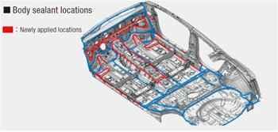  Body sealer application area  Source: Toyota Motor Corp.

Floor panel structure
1.5 GPa-class hot-stamped high-tensile steel is used for the front seat cross member at the rear-end of the front floor. In other vehicles, a seat cross member is used only attached to the front-end of the front seat, but in the new Prius there is also a closed cross section member attached to the back of the seat. This cross member is positioned precisely at a point where it connects to the B-pillar for the purpose of bearing lateral impact energy during a side collision. Connecting the left and right B-pillars also increases the torsional stiffness of the vehicle. This contributes to minimizing the body deformation due to impact from the suspension and improves aspects of dynamic performance including the handling. The seat cross member behind this is positioned under the rear edge of the front seat, between the front seat cushion and the floor carpet where the rear seat occupants slide their toes in. Since a cross member as large as the front-end seat cross member cannot be used in such a tight space, a cross member of reduced height is used in the toe space. However, it is conceivable that 1.5 GPa-class hot-stamped steel is used to maintain high strength and rigidity. | 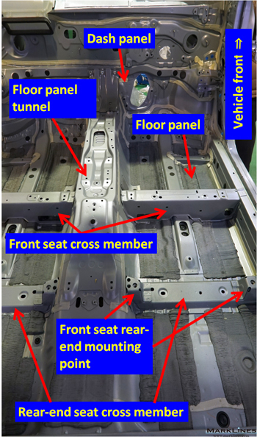  Front floor viewed from the vehicle rear
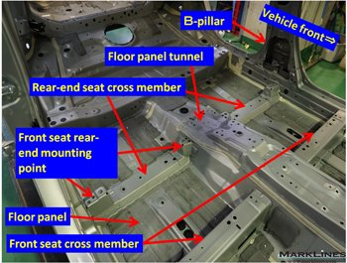
Front and rear floors viewed diagonally from the vehicle front
The front-end and rear-end seat cross members, and the toeboard panel at the front floor and dash panel joint, form an important framework that connects the side sills and floor tunnel, but since the framework is split into right and left sides by the tunnel, reinforcement stays are set respectively under the floor. The three reinforcement stays are made of extruded aluminum, and have identical cross sections designed with weight and cost reduction in mind.

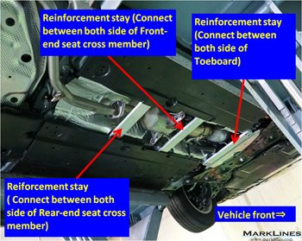 | 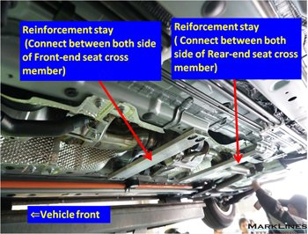
Extruded aluminum reinforcement stays to increase tunnel rigidity under the front floor
Damping material is used in the floor to minimize vibration. Recent Toyota vehicles use coat type damping material. Damping coat can be applied easily to flat surfaces, as well as curved, vertical or other areas with complex shapes. Its adhesive and damping performances have been improved and only a small amount is needed to produce the same damping quality. According to Toyota, the use of the damping coat has achieved weight reduction of 30%.

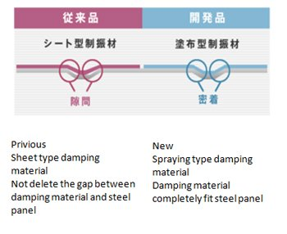  Damping coat has higher adhesion | 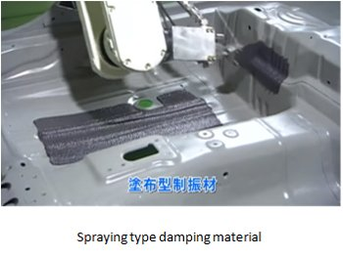  Applied by a robotized coater
Characteristics of damping coat Source: Aisin Chemical Co., Ltd.

Looped structure for the body side
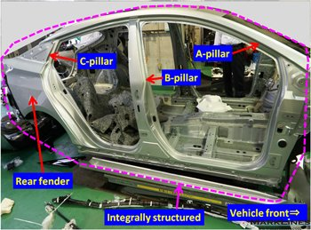 | 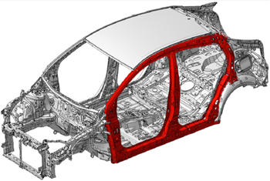
Integrally structured body side outer panel | Looped body side structure  Source: Toyota Motor Corp.

The body side outer panels on the new Prius integrate the A-pillar, B-pillar, C-pillar, and rear fender into one surface. The reason for this is the openings in body sides are the doors, and when they are closed their seal rubber needs to fits tightly to the pillars to seal off rain and wind noise. Making the body side one integrated surface means that there are no seams created for the components of each pillar, and high accuracy of dimension is achieved by not welding, so the seal performance of the door rubber is incorporated tightly and accurately. The inner panels are made of hot-stamped material and ultra high-tensile steel to create a rugged looped structure with high strength and rigidity. The inner panel of the B-pillar is made of 980MPa-class cold-stamped high-tensile steel combined with 1.5 GPa-class hot-stamped reinforcement materials. The roof rail is made of 1.5 GPa-class hot-stamped steel and the side sill is made of 980 MPa-class cold-stamped steel. | 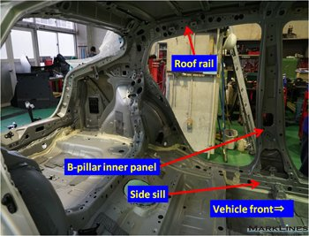  Body side inner panel

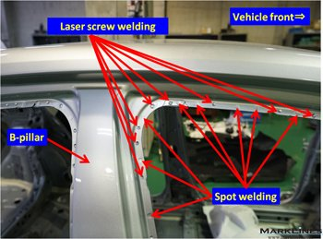 | 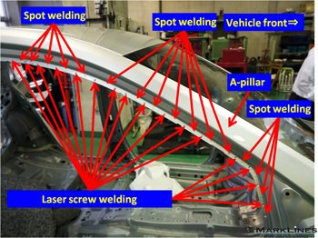
Laser screw welding along the door opening
Recent Toyota vehicles adopt laser screw welding in addition to spot welding. Conventional spot welding requires a spot pitch (the distance between adjacent weld spots) of 25 to 30mm. The laser screw welding method reduces the weld pitch to only about 10mm, which allows for stronger joints between panels and higher body rigidity. The use of laser welding is increasing among European OEMs because it improves body rigidity, but while panels can be joined without gaps, laser welding requires more work time than spot welding. Laser screw welding is a welding process in which "round-shaped" welds are applied at high speeds, so this technique allows body rigidity to be increased efficiently.

Luggage room structure
A unique aspect of the body structure at the back of the vehicle is the location of C-pillar and wheelhouses. A closed sectional framework forms a looped structure that extends from the floor to the rear edge of the roof. This structure is joined at the rear edge of the roof to the closed cross section framework that loops around the rear gate opening to form a rugged and rigid structure. The structure is joined crosswise to the looped structure of the body side mentioned above and lengthwise to the dash panel, which is reinforced with ultra high-tensile steel. As a result, the cabin has a rugged structure in all directions. In an event of crash, its looped structure maintains space for the occupants and guards them from crash impact energy coming from any direction. The strong framework also helps increase the bending and torsional rigidity of the body. This design minimizes twist and flexure of the body caused by large force from the front and rear suspensions, which further contributes to improved handling performance and riding comfort.

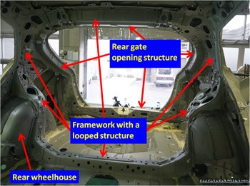  Looped structure integrating the roof, C-pillar and floor | 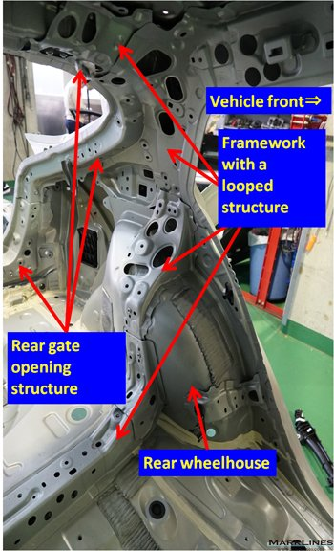  Looped structure around the rear wheelhouse
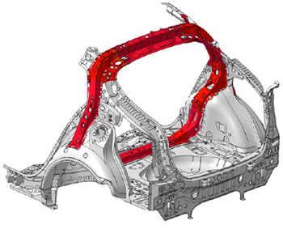
Looped structure at the back of the vehicle
Source: Toyota Motor Corp.

Sound insulation/absorption and damping materials for cabin quietness

Sound insulation in the dash panel
Thinsulate, a brand of synthetic fiber insulation that is very effective for dampening high frequencies, is used on the top portion of the dash panel. The material is also used extensively in various other parts of the all-new Prius to insulate high frequency sounds such as those emitted from the hybrid system inverter. Thinsulate is not used as extensively on Toyota's gasoline-fueled vehicles.
A new sound-insulating material is used for the main part of the dash panel. A perforated sound insulator is attached in front of the conventional felt sound absorber. This creates a structure that allows specific frequencies cancel each other out within the sound insulation material, and efficiently reduces principal frequencies in the engine sound.

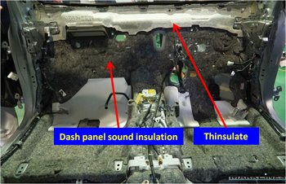 | 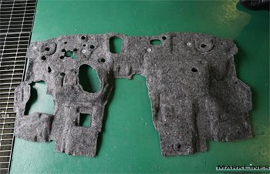
Sound insulation on the dash panel | Sound insulation for the dash panel

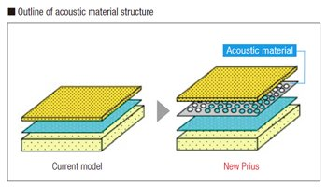 | 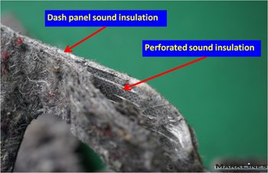
Dash panel sound insulation structure  Source: Toyota Motor Corp. | Perforated sound insulation in the dash panel sound insulator

Sound insulation in the floor
Since the floor silencer (sound insulation) was integrated with the floor carpet, and the area it could be applied was restricted, in the new Prius it has been separated from the carpet. This allows it to be shaped so it fits to the floor and cover its whole surface which increases the freedom of use. Whereas the floor silencer could not cover the seat cross members in previous models, it can now be laid down so there are no gaps and quietness is enhanced.

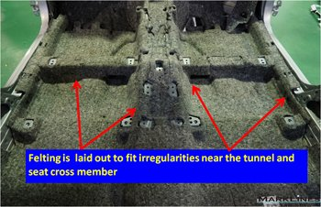 | 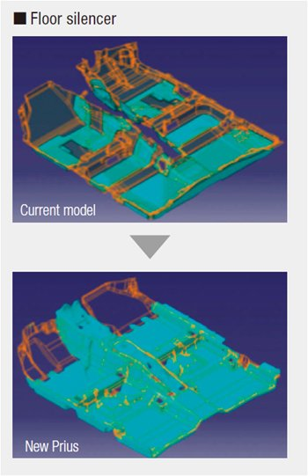
Floor silencer under the floor carpet | Extended use of sound insulation in the floor  Source: Toyota Motor Corp.

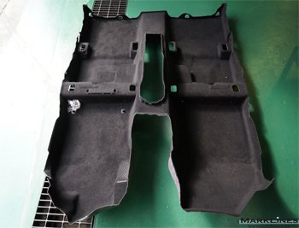 | 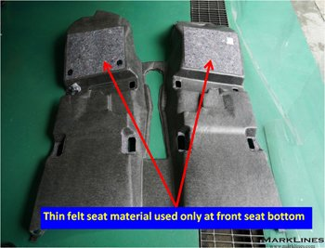
Floor carpet (a thin felt is laid only under the front seat)

Thinsulate for suppressing high-frequency sounds
Thinsulate is applied over almost the entire roof trim. The reason for applying it this extensively is that inverter noise bounces of the roof panel, and since this is close to the ears of the passengers, even a slight acoustic echo can be bothersome. In addition to the dash panel top, Thinsulate is also applied in the door trims and luggage side trims on both sides as well. Since the new Prius has overall quietness improved through improved sound insulation in areas like the floor and dash panel, it is conceivable that high-frequency noise would stand out more. | 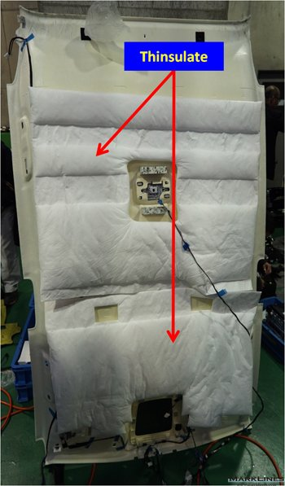  Back of the roof trim

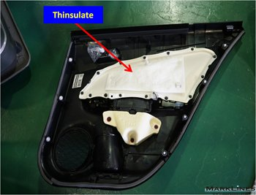 | 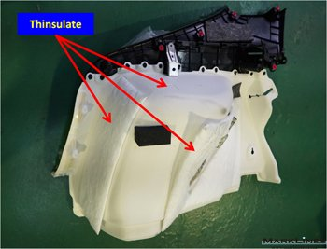
Back of the door trim | Back of luggage side trim

Sound insulation in the engine compartment
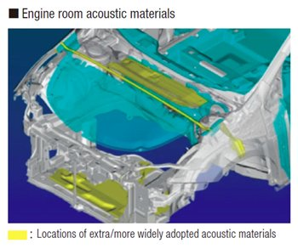 | 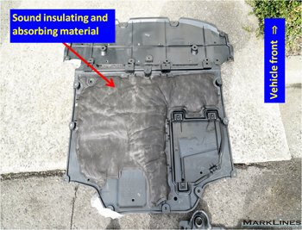
Sound insulation in the engine compartment  Source: Toyota Motor Corp. | Engine undercover top surface

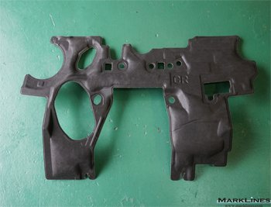 | 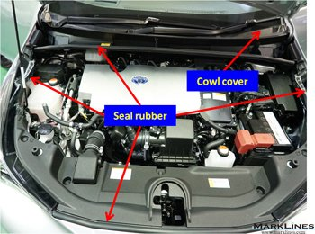
Sound insulation in the engine side of the dash panel | External view of the engine compartment
The engine compartment of the new Prius has premium segment-class sound insulating and absorbing material. The engine undercover completely seals the bottom of the engine compartment, and there are additional materials for sound insulation and absorption. Moreover, the engine hood is designed to shut tightly and prevent powertrain noise from entering the cabin. Seal rubber is applied at the rear edge, both sides and front edge of the engine compartment. The cowl box cavity behind the seal rubber at the rear edge of the engine compartment is sealed with a polypropylene cowl cover to insulate sound. The polypropylene cowl cover connects the space between the dash panel of the body and the dash upper panel fitted with seal rubber to close the gap. Sound insulating and absorbing material is applied to the vertical wall on the engine side of the dash panel. Virtually identical sound insulating and absorbing material is used on the back of the engine hood as well.

